SPRING BOOT
Spring Boot is an open-source Java framework built on Spring that simplifies the development of stand-alone, production-ready applications with minimal configuration.
It removes the need for complex XML configurations and provides auto-configuration, making it easy to create and deploy applications quickly.
How Spring Boot Works?
- You create a Spring Boot project using Spring Initializr (start.spring.io).
- Spring Boot auto-configures your application based on included dependencies.
- Embedded server starts automatically (Tomcat by default).
- You define controllers and services using annotations like @RestController, @Service, etc.
- Run the application with a single command:
mvn spring-boot:run
- Spring Boot handles requests, database connections, logging, and more without extra configuration.
MVC in Spring Boot
MVC (Model-View-Controller) is a design pattern used in Spring Boot for developing web applications. It separates concerns by dividing the application into three components:
- Model (M): Manages data and business logic.
- View (V): Handles UI (HTML, JSP, Thymeleaf, etc.).
- Controller (C): Handles user requests and responses.

How MVC Works in Spring Boot?
Step 1: User sends a request
📌 Example: http://localhost:8080/home
Step 2: Controller processes the request
- Controller receives the request and interacts with the Model.
- Example: Fetch data from a database.
Step 3: Model sends data to Controller
- The Model processes the request and returns data to the Controller.
Step 4: Controller passes data to View
- The Controller forwards the data to the View (JSP, Thymeleaf, etc.).
Step 5: View renders the response
- The UI (HTML, JSP, or Thymeleaf) displays the response to the user.

Implementing MVC in Spring Boot
Step 1: Add Dependencies in pom.xml
<dependencies>
<!-- Spring Boot Web -->
<dependency>
<groupId>org.springframework.boot</groupId>
<artifactId>spring-boot-starter-web</artifactId>
</dependency>
<!-- Spring Boot Thymeleaf for View -->
<dependency>
<groupId>org.springframework.boot</groupId>
<artifactId>spring-boot-starter-thymeleaf</artifactId>
</dependency>
</dependencies>
Step 2: Create Model (User.java)
package com.example.demo.model;
public class User {
private String name;
private int age;
// Constructor
public User(String name, int age) {
this.name = name;
this.age = age;
}

// Getters & Setters
public String getName() { return name; }
public void setName(String name) { this.name = name; }
public int getAge() { return age; }
public void setAge(int age) { this.age = age; }
}

Step 3: Create Controller (UserController.java)
package com.example.demo.controller;
import com.example.demo.model.User;
import org.springframework.stereotype.Controller;
import org.springframework.ui.Model;
import org.springframework.web.bind.annotation.GetMapping;
@Controller
public class UserController {
@GetMapping("/home")
public String home(Model model) {
User user = new User("Alice", 25);
model.addAttribute("user", user); // Adding data to the Model
return "home"; // This refers to home.html in src/main/resources/templates/
}
}
Step 4: Create View (home.html using Thymeleaf)
📌 Path: src/main/resources/templates/home.html
<!DOCTYPE html>
<html xmlns:th="http://www.thymeleaf.org">
<head>
<title>Spring Boot MVC</title>
</head>
<body>
<h1>Welcome, <span th:text="${user.name}"></span>!</h1>
<p>Your age is: <span th:text="${user.age}"></span></p>
</body>
</html>
Step 5: Run the Application
- Start your Spring Boot application.
- Open http://localhost:8080/home in a browser.
- You will see the output:
Welcome, Alice!
Your age is: 25

Key Annotations in Spring Boot MVC
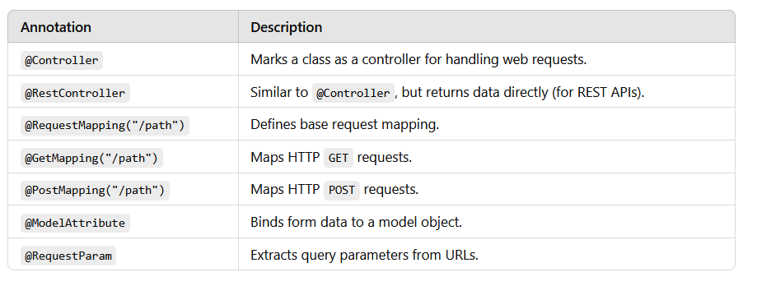
Inversion of Control (IoC) and Dependency Injection (DI):
Inversion of Control (IoC):
- Inversion of Control (IoC) is a design principle in which the control of object creation and dependency management is transferred from the programmer to the Spring container.
- Traditional Approach (Without IoC)
Example: Student student = new Student();
- Developer creates and manages the object
- Tight coupling
- Difficult to test and maintain
- With IoC (Spring Framework)
Example: Student student = context.getBean(Student.class);
- Spring container creates the object
- Dependencies are injected automatically
- Loose coupling

Advantages of IoC
✔ Loose coupling
✔ Better maintainability
✔ Easier testing
✔ Cleaner code
Dependency Injection (DI):
- Dependency Injection is a process by which the Spring container injects dependencies into objects instead of the object creating them itself.
- DI is an implementation of IoC.

Types of Dependency Injection:
1. Constructor Injection:
Dependencies are provided through the constructor.
Example:
public class Student {
private Course course;
public Student(Course course) {
this.course = course;
}
}

2. Setter Injection:
Dependencies are provided through setter methods.
Example:
public void setCourse(Course course) {
this.course = course;
}
DI with Primitive Types
🔹 Primitive Types
- int
- float
- boolean
- String
Skill 5:
A training institute wants to automate the management of student information in a Spring application.
The system should inject details such as studentId, name, course, and academic year into objects without manually assigning values. This Skill demonstrates Constructor Injection and Setter Injection using both XML and Annotation configurations.
Tasks:
1. Create a Java class named Student with fields: studentId, name, course, year.
2. Create a Constructor that accepts all fields and assigns values.
3. Create Setter methods for at least two fields (example: course, year).
4. Configure the Student bean using:
a. XML Configuration - The student should take:
- a POJO class
- an XML configuration file
- a main class to load the container
b. Annotation Configuration - The student should take:
- a POJO class
- a Java class with necessary annotations
- a main class to load the container
5. Create a Spring configuration file (XML or Java-based).
6. Write a main class to load the Spring IoC container.
7. Retrieve the Student bean and print the injected values.
POJO stands for:
Plain Old Java Object
A POJO is a simple Java class that:
- Does not depend on any framework
- Does not extend special classes
- Does not implement special interfaces
- Contains only fields, constructors, getters/setters, and business logic
Step 1:
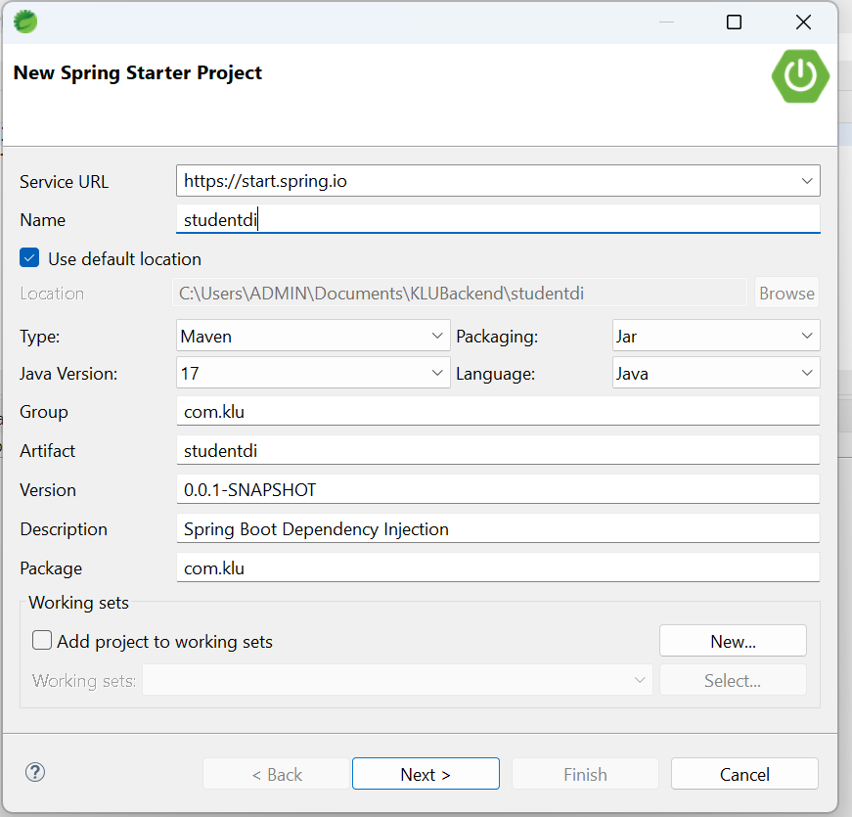
Step 2: Project structure
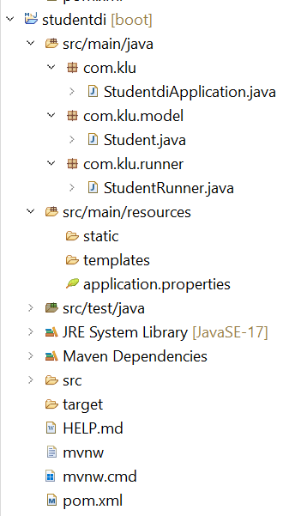

StudentdiApplication.java:
package com.klu;
import org.springframework.boot.SpringApplication;
import org.springframework.boot.autoconfigure.SpringBootApplication;
@SpringBootApplication
public class StudentdiApplication {
public static void main(String[] args) {
SpringApplication.run(StudentdiApplication.class, args);
}}

Student.java:
package com.klu.model;
import org.springframework.beans.factory.annotation.Value;
import org.springframework.stereotype.Component;
@Component
public class Student {
private int studentId;
private String name;
private String course;
private int year;
// Constructor Injection
public Student(
@Value("${student.id}") int studentId,
@Value("${student.name}") String name,
@Value("${student.course}") String course,
@Value("${student.year}") int year) {
this.studentId = studentId;
this.name = name;
this.course = course;
this.year = year;
}
// Setter Injection
@Value("${student.course}")
public void setCourse(String course) {
this.course = course; }
@Value("${student.year}")
public void setYear(int year) {
this.year = year;
}
public void display() {
System.out.println("Student ID : " + studentId);
System.out.println("Name : " + name);
System.out.println("Course : " + course);
System.out.println("Year : " + year);
}
}
StudentRunner.java:
package com.klu.runner;
import org.springframework.boot.CommandLineRunner;
import org.springframework.stereotype.Component;
import com.klu.model.Student;
@Component
public class StudentRunner implements CommandLineRunner {
private final Student student;
public StudentRunner(Student student) {
this.student = student;
}
@Override
public void run(String... args) {
student.display();}}
application.properties:
student.id=301
student.name=Ananya Rao
student.course=Spring Boot
student.year=2025
server.port=8085
Run the application:
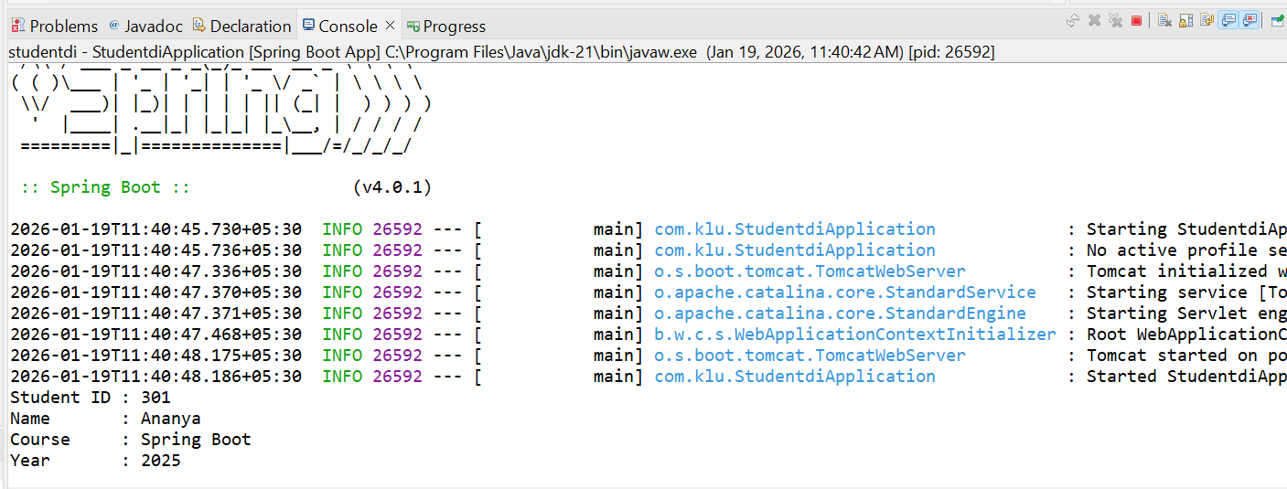

If XML is used:
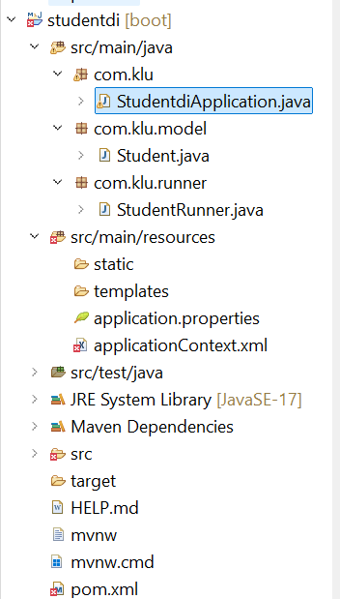
StudentdiApplication.java:
package com.klu;
import org.springframework.context.ApplicationContext;
import org.springframework.context.support.ClassPathXmlApplicationContext;
import com.klu.model.Student;
public class StudentdiApplication{
public static void main(String[] args) {
ApplicationContext context =
new ClassPathXmlApplicationContext("applicationContext.xml");
Student student = (Student) context.getBean("student");
student.display();
}
}
Student.java
package com.klu.model;
public class Student {
private int studentId;
private String name;
private String course;
private int year;
public Student(int studentId, String name, String course, int year) {
this.studentId = studentId;
this.name = name;
this.course = course;
this.year = year;
}
public void setCourse(String course) {
this.course = course;
}
public void setYear(int year) {
this.year = year;
}
public void display() {
System.out.println("ID: " + studentId);
System.out.println("Name: " + name);
System.out.println("Course: " + course);
System.out.println("Year: " + year);
}
}
StudentRunner.java
package com.klu.runner;
import org.springframework.boot.CommandLineRunner;
import org.springframework.stereotype.Component;
import com.klu.model.Student;
@Component
public class StudentRunner implements CommandLineRunner {
private final Student student;
public StudentRunner(Student student) {
this.student = student;
}

@Override
public void run(String... args) {
student.display();
}
}
applicationContext.xml
<?xml version="1.0" encoding="UTF-8"?>
<beans xmlns="http://www.springframework.org/schema/beans"
xmlns:xsi="http://www.w3.org/2001/XMLSchema-instance"
xsi:schemaLocation="
http://www.springframework.org/schema/beans
http://www.springframework.org/schema/beans/spring-beans.xsd">
<bean id="student" class="com.klu.model.Student">
<!-- Constructor Injection -->
<constructor-arg value="101"/>
<constructor-arg value="Ravi Kumar"/>
<constructor-arg value="Spring Framework"/>
<constructor-arg value="2025"/>
<!-- Setter Injection -->
<property name="course" value="Spring Core"/>
<property name="year" value="2026"/>
</bean>
</beans>

Run the application:

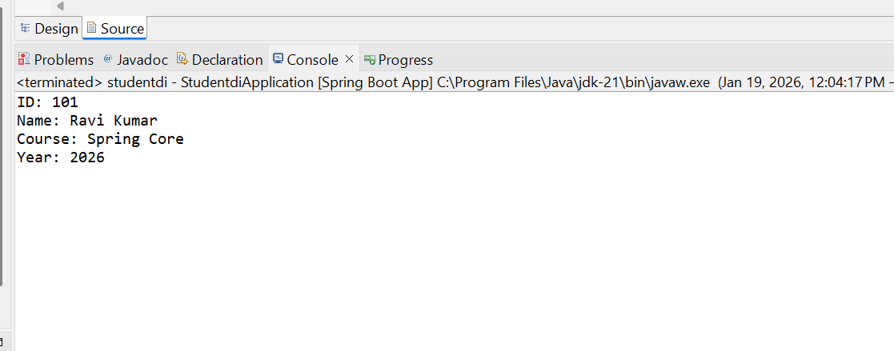

Autowiring:
- Autowiring means Spring automatically injects required objects into a class without explicitly writing configuration code.
Without Autowiring (Manual Injection):
Student s = new Student();
Course c = new Course();
s.setCourse(c);

With Autowiring:
@Autowired
private Course course;

Types of Autowiring:
Constructor Autowiring:
@Component
public class Student {
private Course course;
@Autowired // optional in latest Spring
public Student(Course course) {
this.course = course;
}
}
Setter Autowiring:
@Component
public class Student {
private Course course;
@Autowired
public void setCourse(Course course) {
this.course = course;
}
}

